

WHAT WE DO

Identify the special needs of northern people with a disability and then create awareness everywhere.
Help establish self-help groups in local communities & affect community action.
Help establish a peer support network for people with disabilities.
Work with government and non-government agencies regarding service provision for northern people with disabilities.
To expand opportunities for disabled people to achieve vocational skills and job training
The Gary Tinker Federation for the Disabled Inc is located 408 La Ronge Avenue, La Ronge, SK
(306) 425-6612
(1-866-365-5508)
Box 135, La Ronge,
SK S0J 1L0
garytinker@sasktel.net
The Gary Tinker Federation for the Disabled Inc's main goal is to make long term improvements in the lives of disabled persons that reside in northern Saskatchewan.
The Gary Tinker Federation for the Disabled Inc (G.T.F.) is a non-profit organization established in 1989 to identify and address the needs of disabled persons in northern Saskatchewan

The Gary Tinker Federation is a member of:
- The Northern Labour Market Committee (NLMC)
- Northern Human Services Partnership (NHSP)
- Supported Employment Training Initiative (SETI)
- Cognitive Disabilities Strategy (CDS)
- Disability Income Support Coalition (DISC)
- Affiliate member of Saskatchewan Association of Rehabilitation Centres (SARC)
- Fetal Alcohol Spectrum Disorder (SARC)
- Saskatchewan Mental Health Coalition (Saskatchewan Mental Health Association)

Membership:

Regular membership in the Federation is open to northern persons with a disability (18 yrs and over). Only members of the Federation have the right to hold office and the right to vote.
Become a member today! To find out more call 1-866-365-5508
The Gary Tinker Federation is a community organization open to northern persons with a disability.
It strives to make long term improvements in the lives of disabled persons that reside in the north.
Services offered expand opportunities for its members to achieve vocational skills & job training.
Newsletter

WINTER 2008 20009

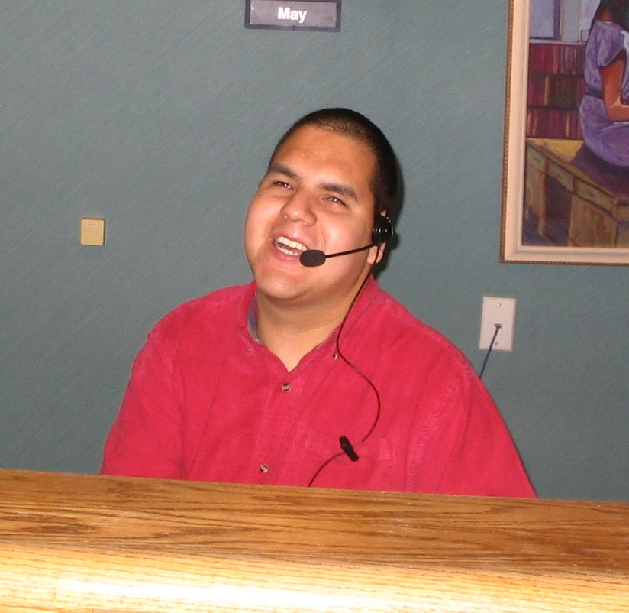

NORMAN’S NEW JOB
Norman Halkett is enjoying his new job at Northern Lights School Division Number 113 office. This transition from school to work placement has been very exciting and challenging for Norm, but with the skills gained from Northlands College, he will be successful. We wish Norman all the best in
his new job and congratulations!

2008 GTF BURSARY
Our 2007 Bursary winner was Robert Ballantyne from Stanley Mission, SK. Congratulations Robert and good luck in your future endeavors!
Watch for updated information in your community or school or call 1-866-365-5508, deadline was Oct 31, 2008 and the bursary winner will be announced at the end of November.

the NEW BOARD MEMBER WESTERN REGION
At our Sept 29, 2008 Fall Meeting our board of directors elected Max Morin as the new board member for the Western Region. We welcome Max and congratulations!.

OUR NEXT GARY TINKER FEDERATION BOARD MEETING
Our next board meeting is scheduled for December 13, 14, 2008 in Prince Albert.

INCOME DISABILITY STRATEGY – FROM NEWS RELEASE SOCIAL SERVICES 08-803
The province today announced the largest-ever investment in programming for people with intellectual disabilities, as well the introduction of a new income plan for people with disabilities.

Guiding Principles:
- More dignified and less intrusive delivery of income support to persons with recognized work-limiting disabilities.
- Recognition of the disability-related costs of going to work and support to individuals with work-limiting disabilities.
- The plan will provide basic income support to individuals with work-limiting disabilities.
- The new plan will be provided with an identity separate from the Social Assistance Plan.
- Delivery of the new plan will be more dignified and less intrusive.
- Reporting requirements will be reduced.
- Opportunities will be provided for people to move in and out of the program as their need requires.

D. Stubel, Executive Director, Office of Disability
Issues will lead the consultation with community stakeholders during the development of these initiatives. The conversation will serve to keep stakeholders informed of goals and progress and to solicit their advice on design and delivery options.

Action response from the provincial government to community based organizations from government news release November 3, 2008
2008 Tax Refunds – Recipients of social assistance programs will be able to keep any 2008 tax refund that is generated from the recently announced tax cuts. 2008 income tax refunds and tax credit received through the Saskatchewan Low-Income tax credit will be excluded from the calculation of social assistance benefits.
Saskatchewan Assistance Programs Mileage Allowance – Mileage rates for the Saskatchewan Assistance Program increased by five cents per kilometre effective Oct 1, 2008. The mileage allowance is available to help clients attend medical appointments, funeral services and other important matters. The new rates are 22 cents per kilometre for a private vehicle and 27 cents per kilometre when a driver is required. An additional two cents per kilometre will be provided for travel north of the 54th parallel. The Province also supports the travel needs of social assistance clients through initiatives such as the monthly mobility travel allowance provided to persons with disabilities ant he Discounted bus Pass Program.
Page 2
Home Heating Allowance – Clients of the Saskatchewan Assistance Program (SAP) will continue to have their actual utility costs paid, based on billings. Clients of the Transitional Employment Allowance (TEA) and the Provincial Training allowance (PTA) will protected from home heating increases. They received a 20 per cent increase to their home heating allowance effective Oct 1, 2008.
211 Telephone Service – “211” has been allocated as a toll-free number to supply the general public with information and referrals to a wide range of community, social, health and government services. The Saskatoon United Way, in partnership with the Saskatoon Food Bank, is leading the drive for a provincial 211 services have been found to reduce the number of inappropriate calls to 911 services. The Province is contributing $30,000.00 to develop a strategy to bring a #211 phone service to Saskatchewan. The telephone-based component is valuable for people who have difficulty using or accessing in-person services, phone directories and websites, including some older adults, northern and rural residents, people with disabilities and people with low levels of literacy. CBO summit participants stressed the need for such a service. Included in the strategy is the development of a web directory that will support the telephone service and allow CBOs to connect and share information.
Long-term Contracts for CBOs – At the CBO summits, some CBOs identified the need for long-term contracts between government and CBO agencies as a priority. For example, an agency that provides support services to individuals with disabilities currently has to apply for funding annually. With this new initiative, the agency may enter into a multi-year contract to ensure funding and promote long-term case a management for individuals in their care. The government plans to enter into long-term funding agreements with CBOs beginning in the 2009/10 fiscal year.
Creating an Open and Collaborative Relationship – Participants attending the CBO summits were told that the unedited results of each of the summits would be made available. The results are posted on the web page at www.socialservices.gov.sk.ca/cbosummit, along with the feedback summaries.

From the Northerner (November 6, 2008 and November 13) by Valerie G. Barnes-Connell
The provincial government announced a multi-year investment of $76.9 million into resources for people living with intellectual disabilities, according to a government news release dated Oct 23, 2008.
The Gary Tinker Federation, one of the eight agencies representing people living with disabilities, will take an active role in direct consultations with the government as the recently
announced $76.9 million Disability Income Strategy for Saskatchewan unfolds and is given shape.
The funds are ear-marked for services for day programs and residential initiatives in an effort to eliminate the “current 440-person waitlist,” according to the news release.
Gary Tinker spent part of the week in Regina in discussions with government leaders in an effort to see some of the monies are spent for people in the north.
Tinker, founder of the Gary Tinker Federation (GTF), an organization with a mandate to assist people living with disabilities, said the funding announcement is important and could help many people.
Tinker will meet with representatives of the Disability Income Support Coalition, of which GTF is a member, in attempt to raise awareness of the needs of people in the north.
The money for group home and day programming is “budgeted immediately so people have to grab the opportunity to design group homes or day programs for the north. Mayors and chiefs should look at it,” said Clarence Neault, GTF coordinator.
GTF is available to provide information about the initiative and while they don’t provide the program and facilities, GTF will “make sue you have the proper people to meet with,” Tinker said. The announcement concerning the creation and development of group homes and day programming comes as good news to GTF, Neault said.
“It’s important to us because right now without it training and employment are difficult. Without a safe environment people with disabilities aren’t fitting into workplaces. It’s difficult for some people; impossible with cognitive disabilities because they are dependent,” he said.
“When people with disabilities work in a work-place they have to have a safe home environment,” Tinker said.
People living with cognitive disabilities are highly vulnerable, both Tinker and Neault said.
Tinker said he wants to see group homes built and day programs established for people in the north because right now people from the north are being sent south away from their families.
“We want to keep them here close to families,” Neault said.
Page 3
With one exception, a group home on the Lac La Ronge Indian Band (LLRIB) reserve, there are no facilities in the north.
The government also announced funds will be dedicated to forming a Disability Income Strategy for Saskatchewan, which is “specifically for people with disabilities, separate from the Saskatchewan Assistance Plan.

PSYCHOEDUCATIONAL ASSESSMENTS
A psycho-educational assessment is a term to describe an evaluation that primarily focuses on an individual’s intellectual abilities and academic skills. These assessments are used to determine strengths and weaknesses in learning, as well as help determine how an individual learns best. The tests assess the following related to learning: Intelligence, language skills, memory, planning ability, verbal and visual learning, attention/concentration, eye hand coordination, reflective/impulse response style.
The tests also assess the following academic skills: Reading (phonetics skills, sight vocabulary, reading comprehension), spelling, writing, mathematics, academic fluency (speed of reading, writing, & calculating), listening comprehension, and oral expression.
A psycho-educational assessment takes approximately five hours of testing time. Interviews with others are sometimes used to help provide some of the required information. Within approximately one week, a report that sets out all the aspects of the testing and provides recommendation is written. Whenever possible, the report is followed up with a formal meeting between the referring agency and the client.
Confidentiality is adhered to in the assessment and report release. Copies are given to the client, the referring agency, the government agency that pays for the assessment (EAPD), and with permission to educational institutions. The Agency that conducts the psycho-educational assessment is Powell & Associates Human Services, located in Prince Albert at (306) 763-7057. Keith Powell is a registered psychologist in Saskatchewan and a member of the Canadian Psychological Association.

NEW STC BUS SERVICE
Effective November 19, 2008 STC scheduled service is available between Prince Albert and La Loche. Further details can be accessed through STC Website: www.stcbus.com or call toll free at 1-800-663-7181.

RECOGNIZING AND WELCOMING OTHERS
We welcome anyone that has questions regarding disability issues to come to our La Ronge office and meet us.

GARY TINKER DISABILITY SUB - COMMITTEE
Our first disability sub - committee of Northern Labor Market sub committee meeting was held in Sept 6, 2008. It went well everyone voiced their concerns regarding the Northern Administrative District. As chairperson for the sub-committee at the Northern Labor Market Meeting November 5, 6, 2008 all concerns were addressed. Minutes available on KCDC website: kcdc.ca

CLIENT STATS 2008
Our client stats have increased each year, our client stats has risen from 389 (2007) to 408 (2008) and growing:

- 6 Client were given the opportunity to participate in training/tutoring.
- 7 Clients participated in Psycho-educational Assessments.
- 19 New clients registered with Gary Tinker Federation from January to November 2008.
- 8 Clients participated in Wage Subsidy & job coaches.



Page 4



Page 5

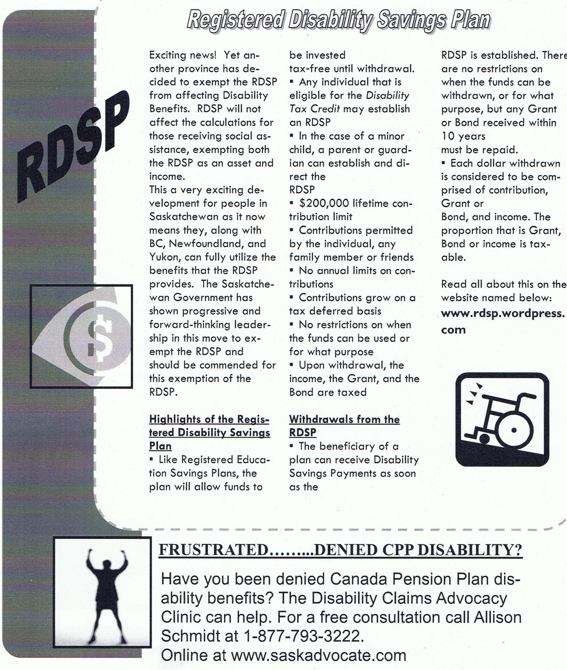

From: Prairie Voice Fall 2008 News Letter
Page 6

OBITUARY

IN LOVING MEMORY

Gilbert Isaac Michel

1942 – 2008
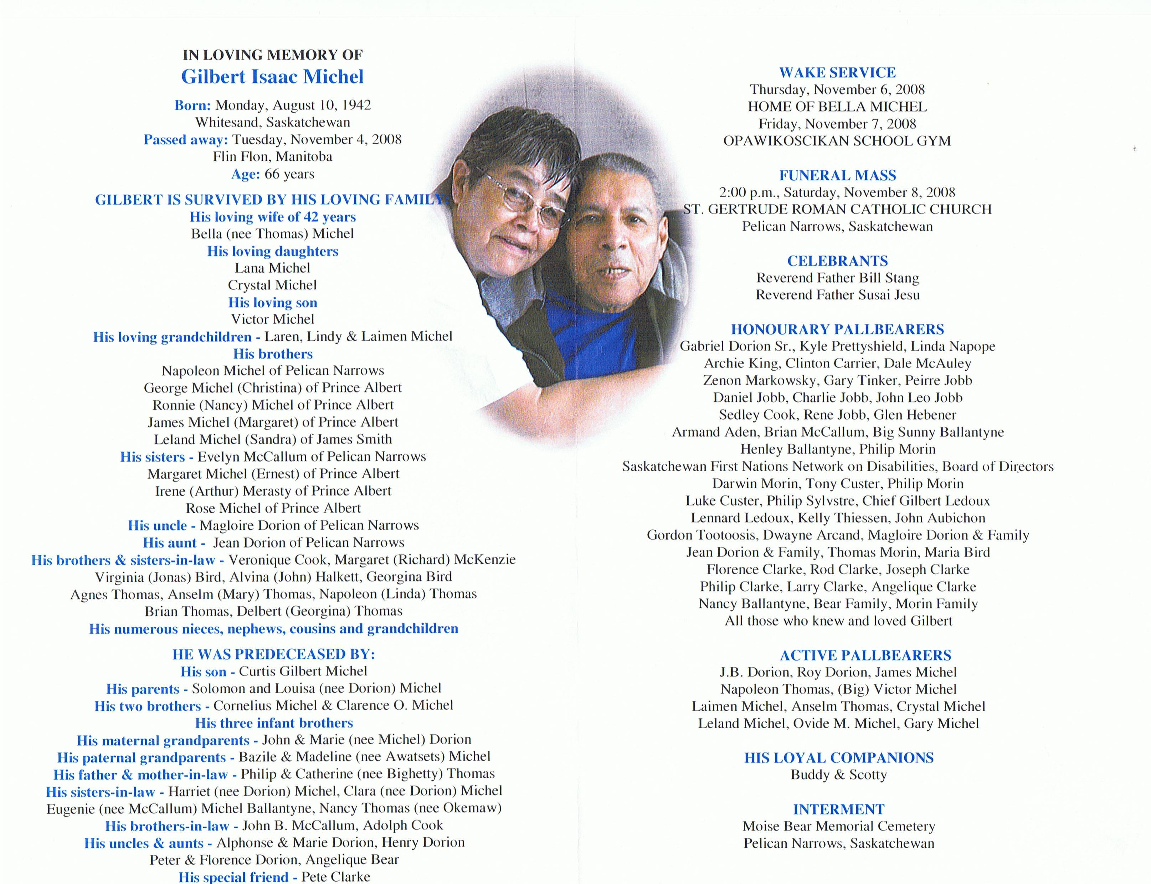

Gilbert Michel served as a board member for the Gary Tinker Federation for the Disabled Inc.

Page 7



GTF STAFF:

Clarence Neault – Coordinator
Phone: (306) 425-4374
E-mail: c.neault@sasktel.net
Randy Stomp – Vocational Counsellor
Phone: (306) 425-4373
E-mail: r.stomp@sasktel.net
Nancy McKenzie – Administrative Assistant
(306) 425-6612
E-mail: n.mckenzie@sasktel.net

Board of Directors:

Calvin Laliberte – Chairperson, Green Lake, SK
Phone: (306) 663-5076
Gary Tinker – Vice-Chairperson, Pinehouse, SK
Phone: (306) 884-4942
Clinton Carriere – Second Vice Chairperson, Cumberland House, SK
Phone: (306) 888-4742
Shane Delaney – Board Member, La Ronge, SK
Phone: (306) 425-5933
Max Morin – Board Member, Ile a la Crosse, SK
Phone: (306) 716-1716
Noah Ballantyne – Board Member, Pelican Narrows, SK
Phone: (306) 425-4796

Page 8





Season’s Greetings &
Happy New Year!

From: Board of Directors and
Staff of the Gary Tinker Federation
for the Disabled Inc.

Page 9

