


WHAT WE DO

Identify the special needs of northern people with a disability and then create awareness everywhere.
Help establish self-help groups in local communities & affect community action.
Help establish a peer support network for people with disabilities.
Work with government and non-government agencies regarding service provision for northern people with disabilities.
To expand opportunities for disabled people to achieve vocational skills and job training
The Gary Tinker Federation for the Disabled Inc is located 408 La Ronge Avenue, La Ronge, SK
(306) 425-6612
(1-866-365-5508)
Box 135, La Ronge,
SK S0J 1L0
garytinker@sasktel.net
The Gary Tinker Federation for the Disabled Inc's main goal is to make long term improvements in the lives of disabled persons that reside in northern Saskatchewan.
The Gary Tinker Federation for the Disabled Inc (G.T.F.) is a non-profit organization established in 1989 to identify and address the needs of disabled persons in northern Saskatchewan

The Gary Tinker Federation is a member of:
- The Northern Labour Market Committee (NLMC)
- Northern Human Services Partnership (NHSP)
- Supported Employment Training Initiative (SETI)
- Cognitive Disabilities Strategy (CDS)
- Disability Income Support Coalition (DISC)
- Affiliate member of Saskatchewan Association of Rehabilitation Centres (SARC)
- Fetal Alcohol Spectrum Disorder (SARC)
- Saskatchewan Mental Health Coalition (Saskatchewan Mental Health Association)

Membership:

Regular membership in the Federation is open to northern persons with a disability (18 yrs and over). Only members of the Federation have the right to hold office and the right to vote.
Become a member today! To find out more call 1-866-365-5508
The Gary Tinker Federation is a community organization open to northern persons with a disability.
It strives to make long term improvements in the lives of disabled persons that reside in the north.
Services offered expand opportunities for its members to achieve vocational skills & job training.
Newsletter

SPRING-SUMMER 2009



2008-2009 GTF BURSARY winner-from northerner Volume 55 number 9
Georgiana Schuring, who just completed her first year in the Social Work degree program at Northlands College is the recipient of the 2008-2009 Gary Tinker Federation Bursary. Gary Tinker presented the cheque for $1000.00 to Schuring March 2, 2009. Schuring, the mother of four children, who are all in school between Grades 1 and 8, lives with Dyslexia. Dyslexia is a learning disability, which affects Schuring’s ability to “put my thoughts into words,” she said. Word blind
another term for Dyslexia, Schuring said, who noted the description is appropriate, because without educational accommodations, she misses or misreads words and not necessarily the more complicated words either. “We’re talking about the was, the is; the smaller words.” Accommodations may be a computer, a scribe or person to write notes, longer times to write exams, or a private room in which to work, said Randy Stomp, vocational counsellor for The Gary Tinker Federation. For Schuring, she has a computer with specialized software and a scribe to assist her; she uses textbooks that have been turned into PDF documents too assist her with her course work. Much of the work done by the Gary Tinker Federation involves supporting people, who suspect they may have a disability, with the diagnosis and assessment process. Stomp said there’s a stigma attached to learning disabilities; he stressed the importance of diagnosis and assessments for people living with disabilities. “Learning disabilities are often hidden. By Val G. Barnes-Connell

OUR NEXT GARY TINKER FEDERATION BOARD MEETING - AGM
Our next AGM board meeting is scheduled for June 20, 21 at the Ramada in Prince Albert.

Breakfast of champions
We are pleased to announce that the February 18th Breakfast of Champions was a success. We at the Gary Tinker Federation would like to thank all who participated. We hope you the “the Champions” will take up Gary’s personal challenge to hire a person with a disability.
There will be another breakfast event in May hope to see you all there.

disability income program task team update
The Disability Community and government are working collaboratively to develop recommendations regarding the design of the new, separate Disability Income Support Program. Community and government task team has been formed and meetings began in early January 2009. The task team is meeting bi-weekly until the end of March.
The task team includes representation from the Disability Income Support Coalition, Provincial Interagency Network on Disabilities, and the Saskatchewan Abilities Council. The members include persons with extensive knowledge and experience gathered through various roles as both service providers and individuals with disabilities.
The task team’s work will be shared with the larger disability community and Social Services staff later this spring to provide input and advice prior to providing final recommendations to the Minister. The task team expects to complete its recommendations in the late spring of 2009.

Cont’ from page 1
Some people would like it to be a dirty little secret you keep hidden, especially people of my generation,” Schuring said. But, Schuring said, she always been quite a vocal person and able to advocate for herself. As her mother was a special needs teacher she knew about her disability, Schuring said. But the same isn’t true for everyone, Schuring said, adding many people living with disabilities are “really an untapped resource to their communities.” “They have a lot of abilities that could be used in a work situation but without people understanding about this type of disability they are often overlooked or discounted as not capable.” People often cycle through different jobs always staying in the entry-level positions because the support resources are not there to give them the understanding and assistance needed. “It’s better to look at the strengths of a person rather than the disability, “she said. The Gary Tinker Federation offers support for psycho-educational assessments, which focuses primarily on “individuals intellectual abilities and academic skills; the assessments are used to determine strengths and weaknesses in learning, as well as to help determine how an individual best learns,” quoted from background information. Different types of learning options need to be in place for people living with learning disabilities, they need to be tailored to the individual’s disability, Schuring said. “People with disabilities are very adaptive and very good at working out where their strengths are,” Stomp said. Schuring who is sitting with an 82 percent grade point average, said she plans to use the money to take an extra psychology course in May and June, once her current school year ends in April. “There’s so many course I’d like to take, it’s like going to a candy shop.” The Gary Tinker Federation Bursary is dedicated to the memory of Clayton Iron and his mother, Velma Iron, both of Canoe Narrows, who both died of Multiple Scleroses. The recipient of the bursary must be a resident of northern Saskatchewan and living with a disability and must be pursuing a Post-Secondary education or enrolled in Post-Secondary classes. The bursary is supported by the Cameco Corporation; Tinker expressed his appreciation to the Cameco Corporation for their support.

GARY TINKER DISABILITY SUB – COMMITTEE
Our first disability sub - committee of Northern Labor Market sub committee meeting was held in Sept 6, 2008. It went well everyone voiced their concerns regarding the Northern Administrative District. As chairperson for the sub-committee at the Northern Labor Market Meeting March 5, 6, 2008 all concerns were addressed. Minutes available on KCDC website: kcdc.ca

PROVINCE LAUNCHES NEW PROGRAM FOR PEOPLE WITH DISABILITIES - From News Release - May 13, 2009
Beginning this fall, thousands of Saskatchewan people will no longer need to depend on social assistance for their basic living costs, following the announcement today of a new income support program for people with disabilities.
"Our government is taking action to improve the lives of people with disabilities," Social Services Minister Donna Harpauer said. "For years, people with disabilities and their organizations have been telling government that they needed a new, dignified, less-intrusive income support program. In this year's Throne Speech, our government promised to ensure that people with disabilities in Saskatchewan receive the support they need, and today we are keeping that promise."
The new program will begin on October 1, 2009, when the first group of recipients - an estimated 3,000 Saskatchewan people with disabilities - will be enrolled and begin to receive benefits. The initial group will be individuals currently on social assistance with long-standing and well-documented disabilities. Over time, enrollment in the new program is expected to reach between 8,000 and 10,000 people.
"We're pleased that the new program will be collaborative, non-intrusive, and impact based, drawing upon many of the key principles recommended by the Disability Income Task Team," Disability Income Task Team Community Co-chair Merv Bender said. "The disability community greatly appreciates having the opportunity to work collectively with government on the development of this historic new program. The work and direction of the task team was confirmed by our many community discussions with people with disabilities, their families and with other Saskatchewan citizens."
Over the winter, the joint community/government Disability Income Task Team met with more than 400 stakeholders. They recently provided Minister Harpauer with recommendations based on these consultations. The new program, which will be separate from the existing Saskatchewan Assistance Program, will be based on the goals and principles recommended by the task team, including:
- To assure a socially acceptable income for people with disabilities - recognizing the range of additional costs associated with disability; and
- To encourage and empower people with disabilities to participate as fully as possible in community life.
"The announcement of this historic new income replacement program is a turning point for people with disabilities in Saskatchewan," Disability Income Support Coalition (DISC) Chairperson Judy Hannah said. "The new program is a testament to all of the hard work by government, DISC and by the members of the Disability Income Task Team on this important issue. DISC is pleased to continue our collaboration with the provincial government as this process moves forward."
A new Community Advisory Committee will be created to continue the successful collaborative approach between government and disability stakeholders.
One of the committee's first priorities will be to work with the ministry on establishing criteria to determine who is eligible for the new program, and to ensure that the new process is fair, effective and fully considers the impact on the individuals enrolling in the program.
The committee will also support the work of the ministry on other details of the new program prior to the October 1 implementation date including:
- Reduced reporting requirements;
- Revised benefit structure;
- Staff training;
- New service delivery approaches; and
- A new program name and separate identity.
"Giving people a greater opportunity to contribute to their well-being is an important factor in helping them to build self-reliance," Harpauer said. "As a government, we are committed to doing our part to ensure people with disabilities participate fully in our society."
The report by the Disability Income Task Team and information gathered during the community consultations is available on the Ministry of Social Services website at www.socialservices.gov.sk.ca. More information about the new income support program will be available as work continues. Clients may contact their local Social Services office if they have any questions.
The new income support program for people with a disability is called SAID – Saskatchewan Assured Income for Disability.

Registered disability savings plan (rdsp) from rdsp fact sheet, hrsdc.
I am pleased to inform you that the Registered Disability Savings Plan (RDSP), and its matching Grant and income-tested Bond are now available to Canadians across the country through the BMO Bank of Montreal. Societe de gerance des Fonds FMOQ Inc. Is also offering the RDSP, Grant and Bond to residents of Quebec. More financial institutions are expected to begin offering the RDSP, Grant and Bond in the coming months. Please visit our website regularly for updates.
The RDSP is a long-term savings vehicle to help parents and others save for the long-term financial security of a person with a severe disability. In general, any person under the age of 60 who is eligible for the Disability Tax Credit and a resident in Canada can establish an RDSP. Beneficiaries do not pay tax on earnings in an RDSP until funds are withdrawn. Anyone can contribute to an RDSP. There is no annual limit, with a lifetime contribution limit of $200,000.

The Government of Canada will also make two types of contributions to the RDSPs of eligible recipients. The Government will pay matching Grants of up to 300 percent, depending on the beneficiary’s family income and the amount contributed. An RDSP may receive a maximum of $3,500.00 in matching Grants in one year, and up to $70,000.00 over the beneficiary’s lifetime. The Government will also pay income-tested Bonds of up to $1,000. A year into the RDSPs of low and middle-income Canadians with disabilities, regardless of the amount contributed. For 2009, the Bond will be available to beneficiaries with family incomes under #38,832. The lifetime Bond limit is $20,000. The Grant and Bond can be paid into an RDSP until the year in which the beneficiary turns 49 years old.
The government of Canada has extended the application period for the 2008 Grant and Bond until March 2, 2009, to provide people with disabilities and their partners and others more time to access the 2008 Grant and Bond. Therefore, contributions made on or before March 2, 2009 will be considered for 2008 Grants. Similarly, Bond applications for 2008 can be made until March 2, 2009. The 2009 RDSP contribution year will begin March 3, 2009.
For more information on RDSP, the Grant and Bond, please visit our website at: www.hrsdc.gc.ca/disability

or call 1- 800-622-6232. For TTY users, please call 1-800-926-9105.

Disability Highlights of the Government of Saskatchewan 2008-09 Budget
Summary from the Honourable Rod Gantefoer, Minister of Finance:
The Government made a commitment to double the Caregiver Tax Credit that provides tax relief to those individuals providing in-home care for an adult infirm dependent relative, or a parent or grandparent aged 65 and over. This budget invests $3.0 million in additional support for the disabled:
• Doubles the Caregiver Tax Credit from $4,095 to $8,190
• Doubles the Infirm Dependant Tax Credit from $4,095 to $8,190
• Doubles the Disability Supplement Tax Credit from $4,095 to $8,190
• Increases the Disability Amount for Self Tax Credit from $7,021 to $8,190 [Finance]
In addition, enhancements are being made to programs for people with intellectual disabilities, such as:
• $2.9 million for a 2.3 per cent salary increase for approximately 300 CBOs, this includes a $1.6 million increase to support a network of

81 CBOs providing residential, day program, advocacy and family support services for individuals with intellectual disabilities. More than 1,300 community-based positions are funded in this sector for a total budget of approximately $75 million
• $2.4 million to support a growing caseload of individuals with intellectual disabilities accessing residential and day programs
• $400,000 increase, to $1.9 million, for the disability housing supplement
• $700,000 increase to support the Cognitive Disabilities Strategy, including $500,000 in enhanced funding to address the growing demand for the program, for a total budget of $2.8 million.

OPPORTUNITIES IN THE PUBLIC SERVICE FOR PERSONS WITH DISABILITIES – FROM NEWS RELEASE MAY 4, 2009
The minister responsible for the Public Service Commission Wayne Elhard is pleased to announce the opportunity for expanded hiring in the Saskatchewan public service for persons with cognitive disabilities. “This expansion of the program will help create a workforce that is more representative of the province’s population and will provide these individuals with opportunities for greater independence, “Elhard said. “It is important to recognize that these individuals are productive workers and are able contribute to the overall wellbeing of the province.” Currently, the Ministry of Social Services’ Valley View Centre in Moose Jaw and the Ministry of Highways and infrastructure both successfully employed persons with cognitive disabilities. Duties in these workplaces include assisting with laundry and cleaning equipment or facilities. Based on the successes in these two ministries, the Public Service Commission is working with hiring managers in government and community-based organizations to expand the initiative to all public service ministries. The employees hired as a result of this initiative will be General Program Assistants. Public service unions have also been consulted, and are on board with the new initiative. “Saskatchewan Government Employees Union (SGEU) has been, and continues to be, supportive of this program to assist persons living with disabilities to access employment within the public service, “SGEU president Bob Bymoen said. “This initiative demonstrates that when union and management work together we can achieve great things.” Canadian Union of Public Employees’ Local 600 President Dave Stevenson was also pleased with the announcement regarding General Program Assistants. “We’ve known for many years the benefits of hiring persons with cognitive disabilities into the workplace.” Stevenson said. “It’s a great way to provide meaningful employment to this group of individuals, and we are pleased to hear the program is expanding to all ministries. Dominic Mancuso, the Co-ordinator of Laundry Services at Valley View, also believes that similar programs across government will be of benefit to persons with cognitive disabilities. “It’s worked very well in our workplace,” Mancuso said. “Our employees with disabilities are gaining employment skills; there is a benefit to the res of the staff, and it creates a positive work environment. The staff takes a protective attitude toward the persons with disabilities and they’re very happy to have them work here.” Currently, 19 persons with cognitive disabilities are employed under this initiative. With the expansion of this program service-wide, Elhard is optimistic this number will increase in the future.

Two PROJECTS FOR GARY TINKER FEDERATION FOR THIS FALL- FUNDED BY SUPPORTED EMPLOYMENT
PROJECT 1: “Improving Life-Career Choices for Northern Youth with Disabilities”. Through trained job coaches from the community, this project will improve job retention and job success for persons with a disability in their home community where the job options and on-the-job resources are limited and the community supports are not always fully developed.
Goals and Objectives: to build capacity and create an environment for sustainable and frequent Job Coach Training by partnering with mainstream labour market stakeholders to extending to them traditional job coach training from the disability sector, adjusted to meet their training needs. This would be delivered, on going, and as required by Northlands College in all of their regional campuses and outreach locations in northern Saskatchewan including Metis and First Nations communities and the Athabasca Basin.

PROJECT 2: “Capacity-building: Job Coach Training” August 2009 To form an ongoing relationship between young people living with a disability in the north’s K-12 school system and Gary Tinker and the services of the federation he founded.
Goals and Objectives:
- To support young people with a disability in their school years.
- To attend career fairs and clinics as a planned event in partnership with school staff.
- To create a relationship of camaraderie and service for youth living with a disability.
- The larger career fairs occur in May. Two are already planned as part of our regular activities. These will be outside the present request but will prove to be a good place for fielding interest to the remote communities who bus in, and who often leaving persons with a disability at home due to lack of suitable transportation, supports or simply because the trip is too demanding on the individuals.

RECOGNIZING AND WELCOMING OTHERS
We welcome anyone that has questions regarding disability issues to come to our La Ronge office and meet us.

20th Anniversary Celebration of Gary Tinker’s Walk (from La Ronge to Regina – 650km in 79 days)
- Gala Supper and Celebration with honoured guests
Elected aboriginal & non-aboriginal officials
- Memorable entertainment experience
- Tickets $25.00/person

DATE: Saturday September 12, 2009

TIME: 4:30 pm

LOCATION: Jonas Robert Memorial Community Centre (Lac La Ronge Indian Band, Far Reserve)

CONTACT: Gary Tinker, Clarence Neault - Coordinator Gary Tinker Federation (306) 425-6612

FOR DETAILS SEE BELOW:

Friday Sept 11, 2009
Northern Disability Conference 9:00 a.m. to 4:00 p.m.

September 12, 2009
Conference 8:00 a.m. 12:00 p.m
20th Anniversary Celebration 4:30 p.m. to 9:00 p.m.

EMPLOY-ABILITY JOB READINESS PROGRAM
for Northerners Living With a Disability

Presented by the Gary Tinker Federation and the Neil Squire Society

The Employ-Ability course is a job readiness classroom program designed for persons with a disability. The course is followed up with employment and career services from our Vocational Counselor.
- COST: The course is free
- LENGTH: Starting October 19, 2009 for 11 or 12 weeks full time - 22 hours per week – every weekday afternoon & 3 mornings.
- PLACE: Office of the Gary Tinker Federation in La Ronge
- REQUIREMENTS:
  - 18 years of age
  - member of Gary Tinker Federation for the Disabled Inc.
  - Grade 6, or equivalent level of learning, literacy
  - willingness & desire to acquire job readiness and/or computer skills
- FUNDING: Eligible for PTA (Provincial Training Allowance).
- SUPPORTS & ADAPTIVE TECHNOLOGY: If the individual requires special computer technology or a one-on-one tutor, application can be made for funding.

PROGRAM DESCRIPTION:
  - The teacher is in Regina at the Neil Squire Society office
  - There are students in Regina and other location(s) live & online.
  - The class in La Ronge will have a learning coach available to help the class learn to use the internet & the computer.
  - Whether in the classroom or at home, everyone listens & talks to each other by speakerphone or earphone or in the internet classroom chat line.
  - Computers are available for each student during the program
- Some individuals may be participating from home by internet and phone, from anywhere in the north.

PSYCHOEDUCATIONAL ASSESSMENTS
A psycho-educational assessment is a term to describe an evaluation that primarily focuses on an individual’s intellectual abilities and academic skills. These assessments are used to determine strengths and weaknesses in learning, as well as help determine how an individual learns best. The tests assess the following related to learning: Intelligence, language skills, memory, planning ability, verbal and visual learning, attention/concentration, eye hand coordination, reflective/impulse response style.
The tests also assess the following academic skills: Reading (phonetics skills, sight vocabulary, reading comprehension), spelling, writing, mathematics, academic fluency (speed of reading, writing, & calculating), listening comprehension, and oral expression.
A psycho-educational assessment takes approximately five hours of testing time. Interviews with others are out; all the aspects of the testing, and provides recommendation is written. Whenever possible, the report is followed up with a formal meeting between the referring agency and the client.
Sometimes it is used to help provide some of the required information. Within approximately one week, a report that sets
Confidentiality is adhered to in the assessment and report release. Copies are given to the client, the referring agency, the government agency that pays for the assessment (EAPD), and with permission to educational institutions. The Agency that conducts the psycho-educational assessment is Powell & Associates Human Services, located in Prince Albert at (306) 763-7057. Keith Powell is a registered psychologist in Saskatchewan and a member of the Canadian Psychological.

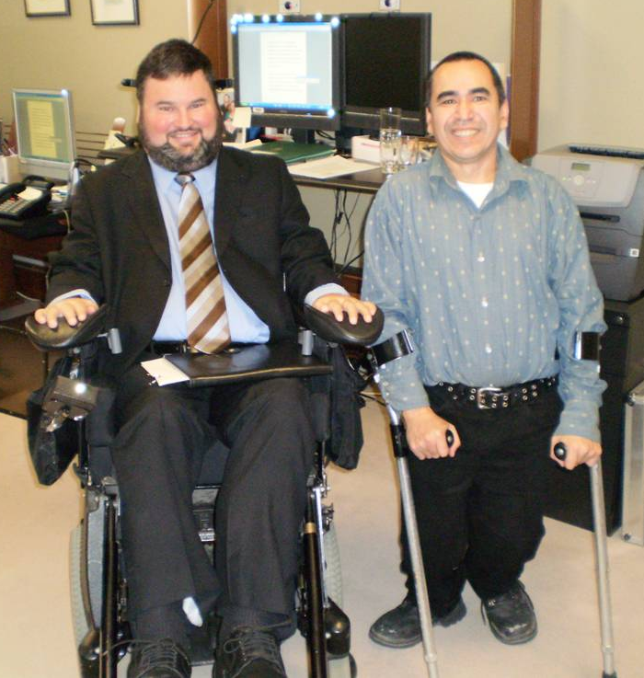

PICTURE OF HONOURABLE STEPHEN FLETCHER
AND GARY TINKER

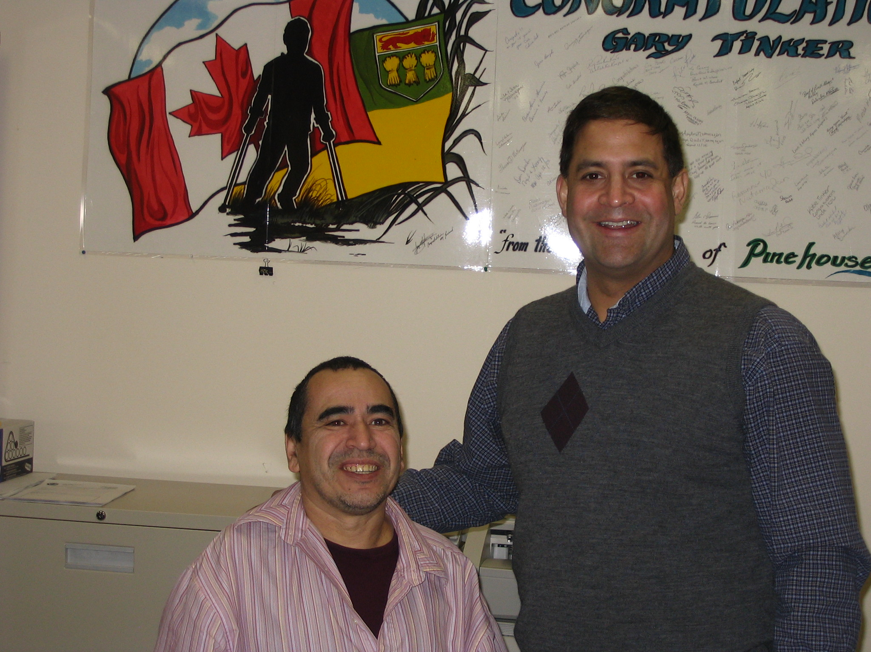

PICTURE OF MP ROB CLARKE – DESNETHE-MISSINIPPI CHURCHILL RIVER

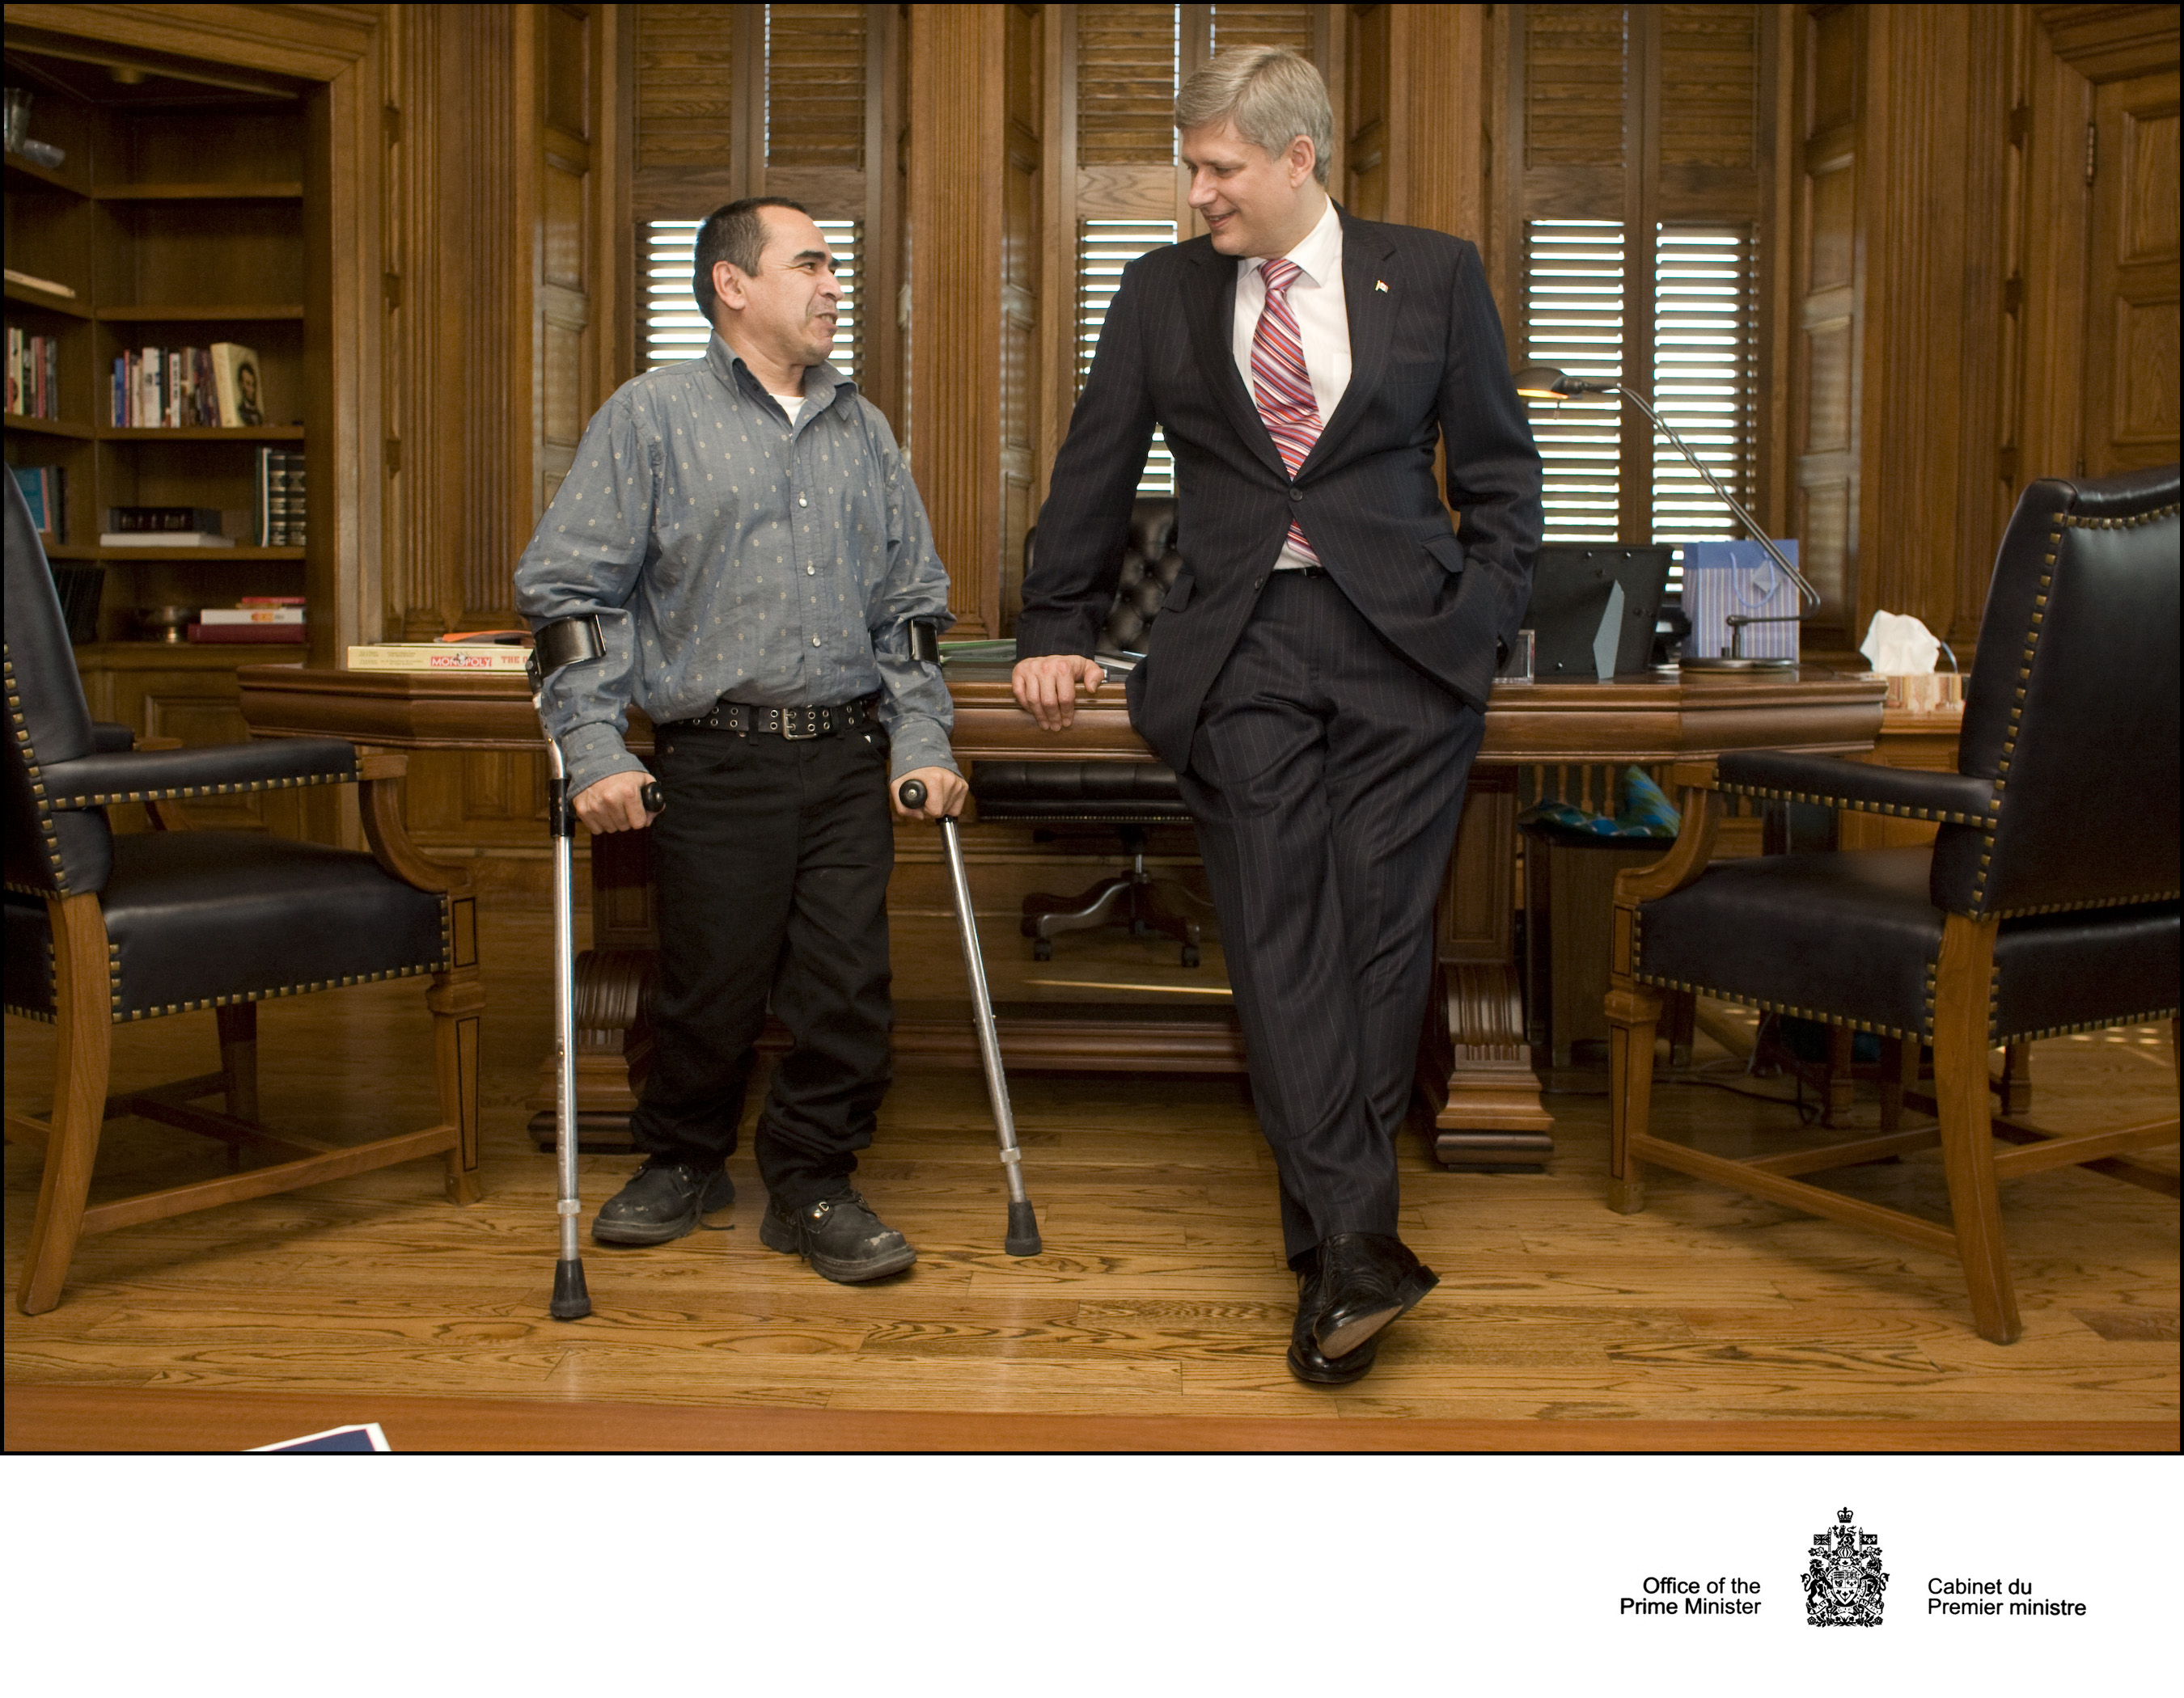

PICTURE OF RIGHT HONOURABLE PRIME MINISTER STEPHEN HARPER

Gary Tinker Federation STAFF:
Clarence Neault – Coordinator
Phone: (306) 425-4374
E-mail: c.neault@sasktel.net
Randy Stomp – Vocational Counsellor
Phone: (306) 425-4373
E-mail: r.stomp@sasktel.net
Nancy McKenzie – Administrative Assistant
(306) 425-6612
E-mail: n.mckenzie@sasktel.net

Board of Directors:
Max Morin – Chairperson, Ile a la Crosse, SK
Phone: (306) 888-4742
Cell: (306) 716-1716
Gary Tinker – Vice-Chairperson, Pinehouse, SK
(306) 884-4942
Clinton Carriere – Second Vice Chairperson, Cumberland House, SK.
Phone: (306) 888-4725
Calvin Laliberte – Board Member, Green Lake, SK
Phone: (306) 833-2729
Shane Delaney – Board Member (Secretary Treasurer), La Ronge, SK Phone: (306) 425-5933
Noah Ballantyne – Board Member, Pelican Narrows, SK
Phone:(306)425-4796
Page 9

